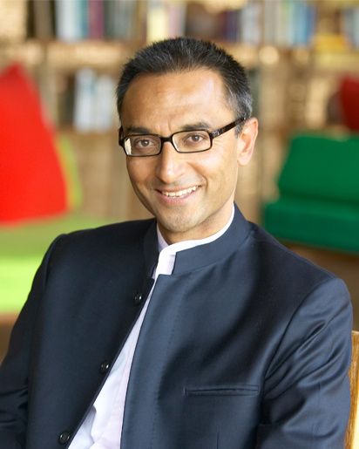
Sonu Shivdasani
Guardian of the Culture
(CEO and Joint Creative Director)

Sonu guards and nurtures Soneva's culture by emphasising the beliefs, values and language that drive behaviour within the organisation. Born in England, he was mostly educated there, with some time spent studying in Nigeria and Switzerland. He is an alumnus of Eton College and a graduate of Oxford University, where he earned an MA in English Literature. During his time at Oxford, Sonu met his Swedish-born wife, Eva. They fell in love with the Maldives and leased an island there in 1990. After some effort and considerable good luck, their first resort, Soneva Fushi, opened in 1995. As a pioneer for luxury and environmental responsibility, Soneva Fushi redefined tourism in the Maldives and soon became known as the country’s premier island destination.

In the same year that Soneva Fushi welcomed its first guests, Sonu and Eva also launched Six Senses Resorts & Spas, followed by the Evason hotels group in 1997, with properties across Southeast Asia and Europe. By 2011, Six Senses had become a globally recognised luxury spa and resorts chain, with 26 resorts and 41 spas. The management contracts for both companies were sold in 2012 as part of Sonu and Eva’s ‘One Owner, One Operator, One Philosophy’ strategy under Soneva.

Alongside the development of Soneva and Six Senses, Sonu pioneered greater environmental accountability within the hospitality sector and beyond. In 2010, the Soneva Foundation was created as a means to reinforce Soneva's SLOWLIFE core purpose. Sonu believes strongly that companies must play their part in addressing the problems of the 21st century. This is possible through small changes that do not affect a company's profitability – in fact, these changes can positively impact a brand's image while raising considerable capital for good causes. Much of the funding for the Soneva Foundation comes from this strategy. Since Soneva banned branded bottled water across its resorts in 2008, filtering, mineralising and bottling its own water on site, the resultant financial savings have supported clean water projects around the world. After developing a carbon calculator to measure Soneva’s direct and indirect CO2 emissions, as well as external emissions such as guest flights and environmental profit and loss along the company’s supply chain, Sonu introduced a mandatory carbon levy on all guest stays to offset this. This levy has funded the planting of half a million trees in Thailand, the construction of a 1.5 megawatt windmill in India, and the distribution of energy efficient cookstoves to rural communities in Myanmar and Darfur, reaching 297,000 people.

In 2008, Sonu hosted the first of the SLOWLIFE Symposium event series, bringing together some of the world’s most impressive environmentalists to problem-solve the greatest environmental challenges. In 2016, Soneva Fushi hosted the Soneva Dialogue, a meeting between the CEOs of the world’s largest fishing companies to agree common targets and set standards for ocean stewardship. The dialogue directly led to the formation of SeaBOS, a unique collaboration between scientists and seafood companies across the wild capture, aquaculture and feed production sectors, seeking a global transformation towards sustainable seafood production and healthy oceans.

In 2019, Sonu convened the island council presidents of three local communities, along with senior government officials, to launch Soneva Namoona, Soneva’s flagship project that reimagines waste management in the Maldives. Namoona means ‘exemplary’ in Dhivehi, the language of the Maldives, and the project models sustainable waste management and radical single-use plastic reduction. Since the launch of the project, the model has been adopted across the whole of Baa Atoll and the Maldives’ government has announced its strategy to phase out single-use plastics by 2023.

While the evolution of Soneva keeps Sonu quite busy, he also enjoys reading, art, architecture, wine, travelling, wellness and island living in general.

Images of Sonu are available at this link.

