Soneva Hosts

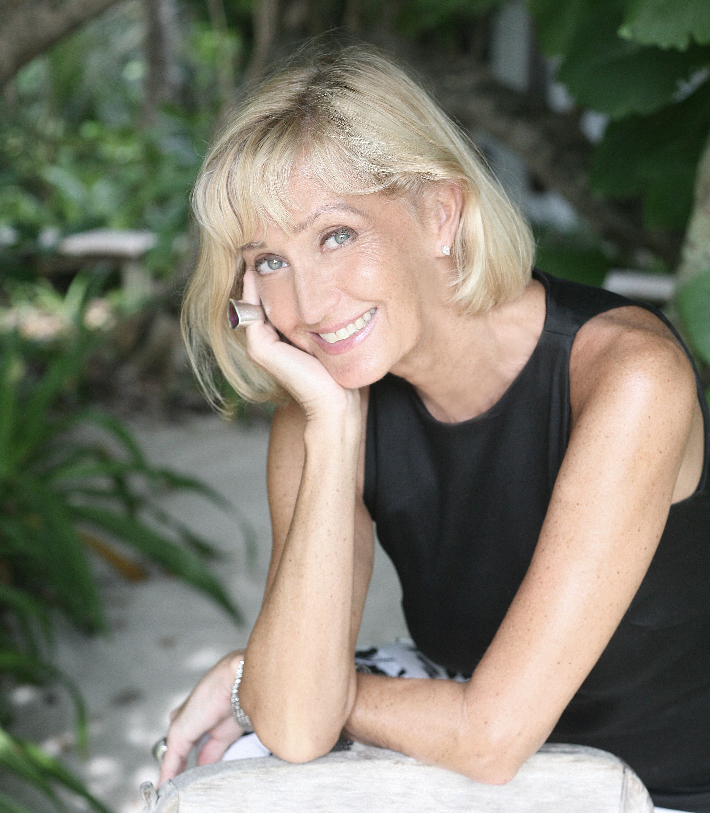
Eva Malmström Shivdasani
Creative Director and Conscience - Soneva

Eva has the challenging role of creating and overseeing all of Soneva’s interior designs. Originally from Sweden, during the 1970s and 80s, she was a top fashion model, appearing on the covers of more than 100 prestigious magazines worldwide. She also ran a successful clothing company, LEVA in Paris, together with her best friend.

She first visited the Maldives at the end of 1970s for a photoshoot. She fell so deeply in love with the country’s beauty, that when she met Sonu in 1986, she brought him there the following year. The rest is history…

Eva is Soneva’s ‘Conscience’, with a philosophy that marries absolute luxury for Soneva guests with her unwavering commitment to using local and sustainable materials, resources and skills.
Passionate about the environment and sustainability, her real flair is in her impeccable taste, innovative and unconventional ideas and her overall daring approach that ensures a different ‘feel’ for every project. Her attention to detail is legendary among her colleagues.

She personally oversees the design of each Soneva villa, incorporating outdoor bathrooms and open-air living spaces that do not require air conditioning. Not a single tree is felled without her approval, not even the smallest branch – instead, villas are built around the trees, and those that are cut are integrated into the design, from bespoke furniture to eye-catching pillars supporting the roofs.
Since the opening of Soneva Fushi in 1995, no plastic has ever been used in Eva’s designs: all amenities are presented in reusable ceramic bottles, and every guest is given a cotton bag so that they can take any plastics, spray bottles and batteries they have brought to the island back home with them for proper disposal. She also placed a box in the giftshop where guests and Hosts could leave their used batteries – and would bring them with her for recycling every time she went back to Sweden.

She ensures that everything that is used or served at Soneva’s resorts is both sustainable, ethical and cruelty-free – and will never use materials or produce that are endangered. Soneva’s hand-woven interiors fabrics were sourced by Eva from a Sri Lankan company that helps rural women find work locally without having to leave their families. Even the pillows and duvets are sourced from a Danish company that is committed to animal welfare, and doesn’t use feather and down from live birds.

Eva instigated the creation of Soneva Fushi’s organic gardens around the year 2000 – today, every Soneva resort has lush island gardens at their heart, nurturing plants and trees for landscaping, and cultivating seasonal fruit, vegetables, herbs and mushrooms for their kitchens.

Soneva’s renowned bicycles were inspired by Eva’s Swedish homeland, where everyone cycles all year round. As well as offering a fun and healthy way to explore Soneva’s winding jungle paths, they also reduce the need to use electric buggies to transport guests, as Soneva Fushi is one of the largest islands in the northern part of Maldives, with large distances for guests to cover.

Eva has been a driving force in protecting the natural environment surrounding each Soneva resort. In 1992, she joined forces with a Maldivian NGO to put a stop to turtle hunting, resulting in the practice being outlawed. She also campaigned for an end to shark fishing in the Maldives, which was finally made illegal in 2010. In 2014, Soneva Fushi became the Maldivian headquarters of the global campaign, ‘I’m FINished with Fins’.

A pioneer against single-use plastics, Eva banned plastic drinking straws back in 1998 and plastic water bottles in 2008, and has played an instrumental role in stopping imported bottled water at Soneva, too. Soneva Fushi had always filtered its own drinking water on site to serve to guests, but in 2010, the resort built a special water bottling plant, producing Soneva Water in reusable glass bottles. Fifty percent of the proceeds from Soneva Water have funded the work of more than 500 global clean water projects and charities. To date, over 750,000 people worldwide have been given access to clean drinking water as a result of this initiative.

Soneva – a dream partnership

Soneva was founded by Sonu Shivdasani with his wife Eva, who met the Monaco Grand Prix.
After they had married, they decided that they would like to open a resort like no other. Both had travelled to many of the world’s most exclusive hotels and resorts and knew what they would NOT like
in their property.

Sonu had the means and the management expertise; Eva the style and design concepts. Together
the young couple wanted to develop a resort that would satisfy their desires for a dream destination
for those who liked to travel in luxurious style. They both also had an overwhelming desire to protect
the environment. What was conceived was a unique philosophy of simple sophistication and returning luxuriously to nature.

They bought an abandoned resort on a far flung 100-acre atoll (Kunfunadhoo Island) in the Maldives and set about creating their dream. Sonu and Eva drew on all their experiences when they planned
the resort.

Images of Sonu and Eva are available here.

